1.3 HW: earthquake

4: Ashley and Maggie

2/11/2020

## open earthquake

earthquake <- read.table("/Users/maggiewesterland/Desktop/school/441/datasets/EARTHQUAKE.txt", header = TRUE)  
attach(earthquake)  
names(earthquake)

## [1] "YEAR" "MONTH" "DAY" "HOUR" "MINUTE" "MAGNITUDE"

minutes - X, magnitude - Y

## summary

summary(MINUTE)

## Min. 1st Qu. Median Mean 3rd Qu. Max.   
## 0.00 15.00 29.00 29.57 44.00 59.00

median > mean suggesting a left skewed distribution, however the numbers are close together so a normal distribution is implied

summary(MAGNITUDE)

## Min. 1st Qu. Median Mean 3rd Qu. Max.   
## 0.00 1.70 2.00 2.12 2.40 6.70

median > mean suggesting a left skewed distribution, however the numbers are close together so a normal distribution is implied

## boxplot

boxplot(MINUTE, horizontal = TRUE)

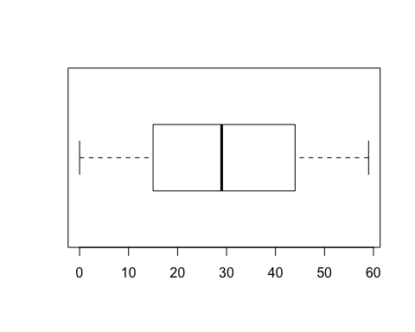 The boxplot does not indicate any outliers for the minute variable.

boxplot(MAGNITUDE, horizontal = TRUE)

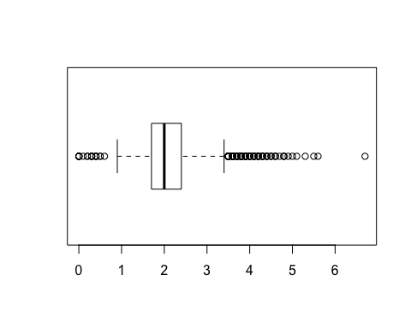 The boxplot suggests a lot of variation in the magnitude with one possible outlier at 6.70.

## scatterplot

plot(MAGNITUDE ~ MINUTE)

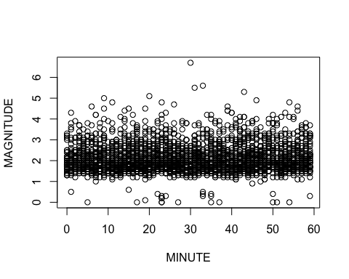 This is a scatterplot where minutes are denoted by the x-axis and magnitudes are denoted by the y-axis.